Performance Test Approach & Plan



Revision History

|  |  |  |  |  |  |
| --- | --- | --- | --- | --- | --- |
| Version Number | Date | Prepared By | Reviewed By | Approved By | Summary of Changes |
| V 1.0 | 12/10/2020 | Rohit Kappikare |  |  | Initial Draft |
| V1.1 | 2/23/2021 | Rohit Kappikare |  |  | Updated Finance Details |
|  |  |  |  |  |  |

**Table of Contents**

1 Introduction 4

2 Application Overview 4

3 Performance Test Goals and Objectives 5

3.1 Web Interface 5

4 Scope & Constraints 6

4.1 In Scope 6

4.2 Out of Scope 6

4.3 Constraints 6

5 Testing procedure 7

5.1 Entry Criteria 7

5.2 Test Data Requirements 7

5.3 Test Activities and Deliverables 7

5.4 Workload criteria 8

6 Performance Test Strategy 9

6.1 Scripting 9

6.2 Test Executions 9

6.2.1 Load Test 9

6.2.2 Spike Test 10

6.2.3 Endurance Test 10

6.3 Monitoring 10

6.4 Test Reporting 11

6.5 Schedule 11

7 Test Environment 11

7.1 Tools Used 11

7.2 Environment Setup 11

7.2.1 System Under Test 12

8 Assumptions 12

9 Dependencies 12

10 Risks & Contingency 13

11 Appendix 13

# Introduction

This document, prepared by Cigniti defines an approach for performance testing of Wales and West Utilities projects. It includes the objectives and the approach to achieve these objectives.

# Application Overview

WWU is performing a digital transformation programme (Link Programme) across all aspects of the business and technology stacks. Part of the business wide Link programme is the SAP Link programme which will result in the reimplementation of the SAP landscape in line with the latest SAP strategic roadmaps and best practices. The SAP Link programme will deliver the latest cloud and on-premise SAP solutions working together to deliver the WWU capabilities needed to deliver the defined business processes.

***Figure 1: High-level Architecture***

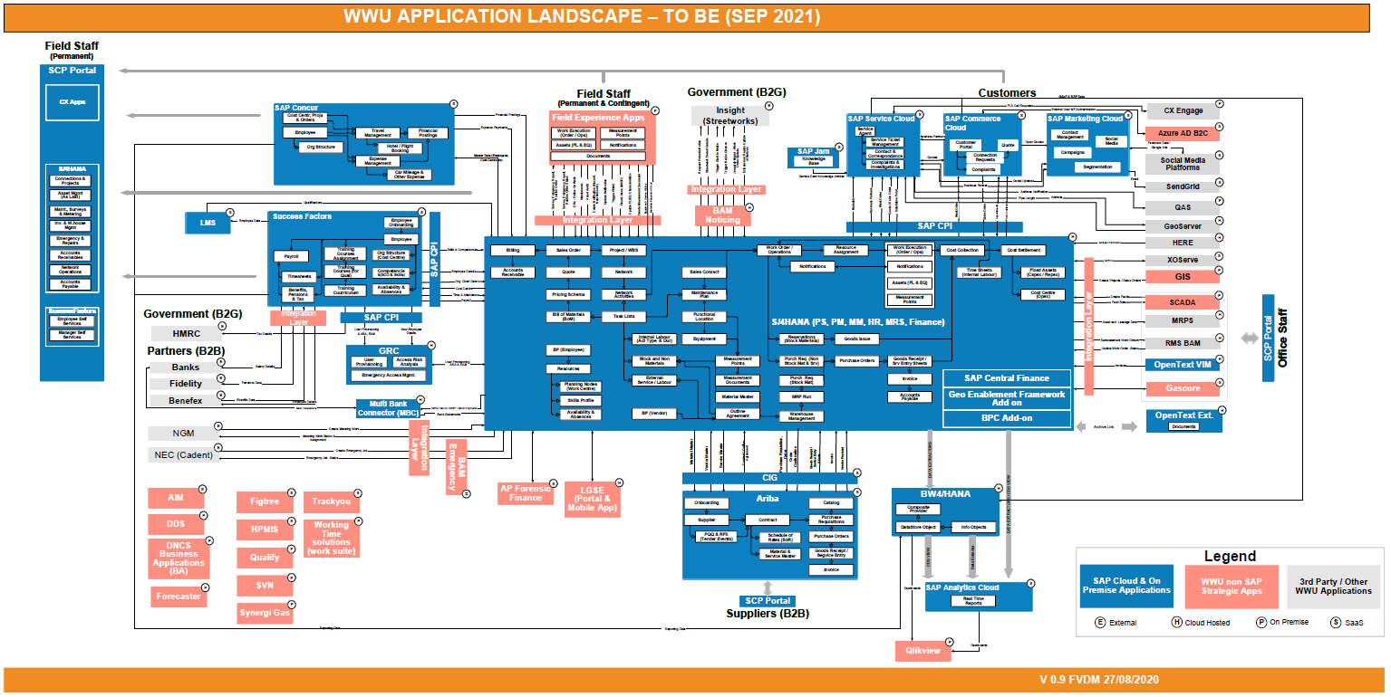

# Performance Test Goals and Objectives

Lists performance requirements / goals of different interfaces, which are in scope of this project

## Web Interface

* Average response time of all transactions must be less than **_2__** seconds.
* Total number of errors resulting while processing must be less than **___** (it will be filled later or decision will be taken after the performance run)
* SAP Solution Manager will be used for monitoring. The metrics supported by SolMan will be collected and included in the performance report.

# Scope & Constraints

## In Scope

Finance application is in scope for Phase 1 performance testing. Please find below the scenarios in scope.

|  |  |
| --- | --- |
| S No | Test Scenario |
|
| 1 | Payment Run – BACS payment Generation of Payment proposal |
| 2 | Generate Trial Balance Report |

Components in scope

The purpose of this performance testing engagement is to validate the following items and overall would like to sense the stability of application and infrastructure –

* Response times for web application (SAP Fiori).
* High Availability.

Activities in-scope

* Obtain and consolidate the Performance test requirement
* Gather detailed information and prepare performance test approach (this document)
* Script the identified business flows in the performance environment identified for Performance Testing
* Execute the performance tests as designed
* Monitor the identified metrics in order to observe their behavior during test runs.
* Analysis of the results of the performed executions
* Prepare and publish the preliminary reports and executive summary report

## Out of Scope

* Setting up of application(s) / environment(s) under test with sufficient volume of data in backend
* Developing any kind of simulators, stubs or interfaces to emulate 3rd party systems
* Implementation of Performance tuning recommendations
* Any additional type of testing (Functional, Security). However, functional validation will be done once before proceeding with performance test scripting
* Activities/Services that are not explicitly stated in the scope are out of scope for this engagement
* Performance Testing of functionalities that are not in scope
* Performance testing/monitoring of any third-party interfaces
* Code profiling / Hardware sizing / Capacity planning
* Security / Vulnerability testing / UAT/ Whitebox testing

## Constraints

Constraints are items that limit testing. Testing can only occur to a certain level because of the constraints in

simulation, list such constraints here

* Awaiting confirmation on User Mix
* Delay in access to the application

# Testing procedure

## Entry Criteria

* The following pre-requisites must be met without fail for the successful implementation of the various performance testing activities.

Table 1: Entry Criteria

|  |  |
| --- | --- |
| **Phase** | **Entry Criteria** |
| Discovery Phase | * The performance test requirements for Application under test are identified |
| Test Plan | * Business critical transaction(s) and scenario(s) to be tested are defined * The application walkthrough/KT is provided |
| Test Development | * Functionally stable application is available * Approved and Signed off Traversal Flow document * Test environment is configured and ready for testing * The application build is deployed in the testing environment |
| Test Execution | * Functionally stable application is available for Test executions * Application set-up completion in the Performance Test Environment * Availability of Test Data * Completed Test scripts and scenario design |

## Test Data Requirements

* Invoices with large amounts to be created, which will be used as an input to automated payment run
* 50 test user Id’s are to be created with the Account payables account role to generate payment proposals
* 50 test user Id’s are to be created with GL accountant role to execute/ generated Trial Balance reports.
* Business partner , Activity code assignment , AP, AR invoice &credit accounts and GL accounts (open items) data is replicated from ECC to S/4

## Test Activities and Deliverables

*The section lists out the Include the test deliverables for each phase in this section.*

Table 3 : Test Deliverables

|  |  |  |  |
| --- | --- | --- | --- |
| **S.No** | **Performance Testing Phase** | **Activities** | **Deliverables** |
| 1 | Discovery | * *Understand functionality and technical architecture of WWU SAP applications* * *Obtain access to test environment* * *Gather and collate performance testing requirements* * *Understand production usage trends, build workload model and user profile. Identify metrics to measure.* * *Conduct tool feasibility with LoadRunner and JMeter* * *Setup load generation environment* * *Build reporting and monitoring templates* | * *Performance test approach* * *Reporting and monitoring templates* |
| 2 | Test Design | * *Develop performance test scripts for identified workflows, interfaces and batch jobs using selected tool* * *Identify and validate test data requirement* * *Debug scripts using multiple records of test data* * *Customize prepared scripts to handle errors* * *Publish status reports* | * *Performance Test Scripts* * *Status reports – Daily and weekly* |
| 3 | Test Execution | * *Conduct smoke test and modify scripts, if needed* * *Conduct 2 rounds of performance tests to check the scalability and break point* * *Publish status reports* * *Provide an interim test report for the tests executed* * *Monitor servers using perfmon and SAP monitoring tool.* | * *Preliminary Test Reports* * *Status reports Daily and Weekly* |
| 4 | Analysis and reporting | * *Analyse client and server-side performance metrics* * *Review and publish performance test report including client side and server-side observations* * *Obtain sign-off on all deliverables from WWU* | * *Comprehensive performance test report with thorough analysis* * *Handover Performance Test Assets* |

## Workload criteria

|  |  |  |
| --- | --- | --- |
| S No | Test Scenario | User Load |
|
| 1 | Payment Run – BACS payment Generation of Payment proposal | 50 |
| 2 | Generate Trial Balance Report | 50 |

# Performance Test Strategy

## Scripting

* Tool selected after performing the feasibility study will be used for generating the load on Web application and API’s
* Dependent transactions will be scripted in a single script
* Best practices that will considered while scripting would be as follows:
* Ensuring that the script doesn’t contain incorrect or extraneous URLs. The URLs specified should be in correct sequence
* Parameterize scripts to support dynamic data set
* Use proper checkpoint(s) / assertion(s) for all steps involved in the transaction
* Ensures that the performance test tool handles cookies automatically
* Ensure that proper think times and Iteration pacing times are specified in the script
* Scripts should be written in a way so that it can be executed against multiple environments without any significant changes
* Final scripts should be representative of actual user activities
* Look out for re-usability while designing the scripts
* Follow standard naming conventions and folder structures

## Test Executions

Performance test executions will start after the final data loads are completed for the respective applications and all the required data is setup. In case performance testing has to be done in parallel with UAT we can consider the below:

Conduct the performance test in parallel with UAT in non-business hours. If the business scenarios to be tested deal with read only operations then we do not anticipate any major impact on UAT execution. However if the business scenarios to be tested deal with creation of data then we would need the help of functional teams to help with inactivating the data created as part of performance testing or Basis team might have to reload the applications with the refreshed data after performance testing.

### Load Test

1. Load Testing will be conducted on the WWUtilites applications with the identified number of concurrent users.
2. Load Pattern:
   * Ramp-up: 1 vuser will be ramped up for every 10 seconds.
   * Steady state duration: 1 hour
   * Ramp-down: 1 vuser will be ramped down every 10 seconds.

### Spike Test

1. Spike Testing will be conducted on the WWUtilites applications with the identified number of concurrent users.
2. Load Pattern:
   * Ramp-up: 1 vuser will be ramped up for every 10 seconds.
   * Steady state duration: 20 Min
   * Introduce VUsers rapidly
   * Steady state duration: 20 Min
   * Rapid Ramp-down: Ramp down the VUsers introduced as part of Spike test rapidly.
   * Steady state duration: 20 Min
   * Ramp-down: 1 vuser will be ramped down every 10 seconds.

### Endurance Test

1. Endurance Testing will be conducted on the WWUtilites applications with the identified number of concurrent users and the system will be tested for long duration of 8 hours in order to observe whether the system is able to sustain for the whole duration or not
2. Load Pattern:
   * Ramp-up: 1 vuser will be ramped up for every 10 seconds.
   * Steady state duration: 8 hours
   * Ramp-down: 1 vuser will be ramped down every 10 seconds.

## Monitoring

* Key performance indicators like response time, errors percentage and throughput (tx/sec) will be monitored from remote machine using Load Runner on a regular basis
* Key resource utilization metrics like cpu, memory, disk and network i/o will be monitored using PerfMon
* Performance run will be stopped in between in case key metrics listed above are suspicious (not normal)
* System under test is not available or not responding at all
* Load generation machine can’t generate enough load
* All transactions are resulting as errors
* The problem will be investigated by Cigniti team first and then if required will be escalated to Wales and West Utilities team for the resolution
* After every stop or start of the performance run, the same will be communicated to all stakeholders

## Test Reporting

* Performance key indicators will be collected for the each run mentioned in the Execution strategy separately
* Report will have information of Response times, Errors Percentage and Transactions per sec (Throughput) and any identified server side bottlenecks.

## Schedule



# Test Environment

## Tools Used

Please find below the tools used for Performance testing activities

Table 4: Tools Used

|  |  |  |  |  |
| --- | --- | --- | --- | --- |
| **S. No** | **Tool** | **Version** | **Protocol** | **Owner** |
| 1 | JMeter | 5.4 | HTTP/HTTPS | Open Source |

## Environment Setup

Wales and West Utilities will setup a dedicated test environment for performance testing. In case Wales and West Utilities requests a subset of the scenarios to be executed in Production Environment then Cigniti team would need the exact scenarios to be executed in Production Environment to be provided in advance to understand the impact if any which might be caused due to execution in Production Environment. Cigniti team will not be liable for any failures or data corruption issues that might occur in Production Environment because of this testing.

Performance testing will be done in non business hours so that UAT is not impacted. Payment process will be stopped at payment proposal generation stage in order to reduce/mitigate the impact on existing data. Reset and reversal items to be performed if required

### System Under Test

The Performance environment will be used for the Performance Testing.

# Assumptions

|  |  |
| --- | --- |
| **Sl. No.** | **Assumptions** |
| 1 | The Performance Test environment must be available in time to avoid any delay in performance testing schedule |
| 2 | Wales and West Utilities will assign a single point of contact for the Cigniti team to liaison / solve the issues in the system under test setup |
| 3 | All test scenarios identified for performance testing will be signed off by Wales and West Utilities prior to test run |
| 4 | All scenarios related to performance testing have been validated / verified in terms of functionality before conducting performance testing |
| 5 | Cigniti would provide a list of the performance tools to be installed on the server at the end of the discovery phase. These will be enabled by Wales and West Utilities personnel / Cigniti will be provided access to do so. |
| 6 | System under test (SUT) will be set up by Wales and West Utilities and the required access will be provided. All change control requests for the System under test will be handled by Wales and West Utilities. Wales and West Utilities will own the responsibility for a stable SUT. |
| 7 | Cigniti team will be provided access to the system under test and load generation environment through VPN |
| 8 | Wales and West Utilities Single point of contact will orchestrate the required support resources (Development, Server support, DBAs, etc.) during performance testing effort by Cigniti teams. Cigniti will notify the schedule of the performance test to the Wales and West Utilities SPOC well in advance and ensure coordinated execution efforts from both parties |

# Dependencies

|  |  |  |
| --- | --- | --- |
| **Sl. No.** | **Dependencies** | **Responsible Team** |
| 1 | Higher amount invoices need to be created, which used as an input to automated payment run | Functional Team |
| 2 | 50 test users login with the Account payables account role to generate payment proposals | Functional Team |
| 3 | 50 test user login with GL accountant role to execute/ generated Trial Balance reports. | Functional Team |
| 4 | Business partner , Activity code assignment , AP, AR invoice &credit accounts and GL accounts (open items) data should be replicated from ECC to S/4 | Functional Team |

# Risks & Contingency

|  |  |  |  |  |  |
| --- | --- | --- | --- | --- | --- |
| **Sl. No.** | **Risk** | **Probability** | **Impact** | **Severity** | **Mitigation** |
| 1 | Test Environment  Unavailability / downtime | High | Delay in project  timelines | High | Wales and West Utilities will assign a single point of contact for the engagement who will be notified of any issues lasting for more than 1 hour |
| 2 | User ID’s for Performance Test | Medium | Users cannot perform the required actions for scenarios | High | Fix the performance IDs and validate all the access and ensure users are working as per design. |
| 3 | Functional Issues | Low | Delay / Abort load tests | High | The performance test scripts fail due to functional scenario failure. This could lead to severe loss of productivity. Validate the functional flows and conduct smoke run for test scripts before the execution. During the run, monitor the execution, in order to be able to catch such exceptions and abort the run. |
| 4 | User Roles for accessing the trial balance reports | High | Delay / Abort load tests | High |  |

# Appendix